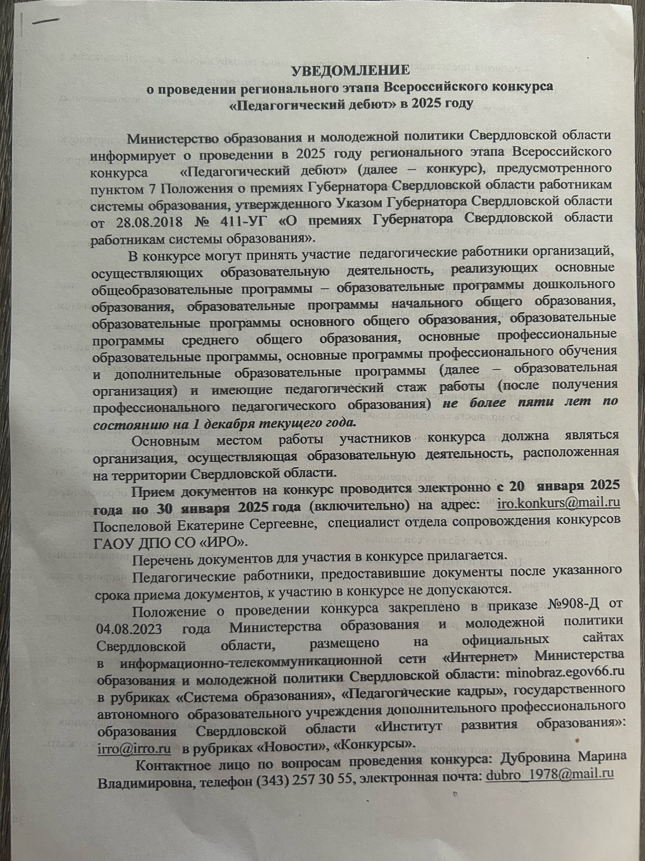

# RKsMnrlv7V3R9nOfW-ilLCxFjlHQPuGBFyl5X1h1IC4l1I4iB75y8zMBcz64pQvt9bjrymZcS8CJbFJdzXWk1832.jpg

# L42pIOqgxz8evHhJ-fgWc9Pw6FnY_rCEic0y5RFuQ0GAC4bQLVwDwEEtSqmEzDtDFu5DM__KQZir0oh6YQztR2UL.jpg

# haXpiibdvV8CxAOrjaSKPkMMwwBh-xwFXbHE0qG1fWklzhBdK3SK1DcGW3ImAk-d55WMOqrQP2O7c9GLeqOWAbnt.jpg

# JEuoCh-pC10jRG5J4jVkriqaUBW8mOxPCjinr2wIIZjcemXQD3tWc2q4bMWoYLB4eIOT8ruLMWYAYfBk8mcmoiqO.jpg

# kYc7FYSn9HRiju9HDAqpxnkCO3s0LVBi364ebXC9VDxv32_LXWcaGUPN2yWnI2jX4OwB3ci8njlnk8gsu3o-cJYo.jpg

# Приказ Педагогический дебют.png

# YQOA7gWhJuYrduKREogcHTPdxD_o3CqWtC_k0nI5_p2tLv4Sn5xgZ4nZxxWWHzEji1xjBd4rScn8k10GkM5C279x.jpg